AWS Data Warehousing and BI

# Data Warehousing:

Amazon Redshift allows us to query gigabytes of structured data in the data warehouse, database and data lake using SQL. The queried data is stored in S3 Data lake which can be further analyzed with amazon’s analytics service like Athena. This will be later discussed in this section below but for now let’s talk about DWH and Redshift.

## The Process:

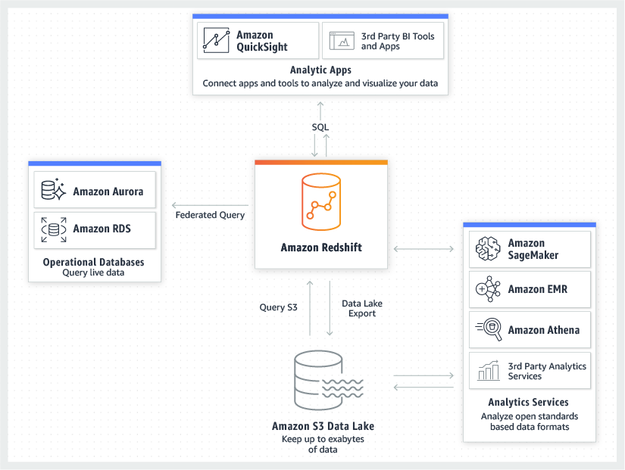Amazon Redshift cluster is the first step in creating a data warehouse, which is a node. You can upload your data set after provisioning your cluster, and then perform data analysis queries. Amazon Redshift console can be used to do this in an interactive way, or if you are programmer then Amazon Redshift Query API can manage cluster programmatically.

After this comes the Database, here you will load the data and run queries on it. Here Amazon Redshift uses parameter groups to define the behavior of all databases in a cluster.

Since the Amazon Redshift Data Warehouse is a cluster it uses many compute nodes and has a leader node that handles communication between other compute nodes. This is further explained in Amazon cluster management.

After this you can load your data into the data warehouse cluster like for example from Amazon S3 Data Lake like mentioned in the above picture.

After this you can use the analytical services like Athena for your data warehouse and store the queried data in the data lake again.

# Business Intelligence (Amazon Quick Sight)



Amazon QuickSight is a machine learning power BI tool which helps create helpful and interactive dashboards for your data which is taken from your data warehouse. Since it is a serverless architecture there is no need to configure or manage your server. With a set of SDK’s and API’s you can configure the look of your dashboards easily for your convenience. QuickSight offers pre-built models for machine learning or you can import your own models using Amazon SageMaker. You can either summarize the business metrics or you can use machine learning to do it for you which can also make predictions to some extent.